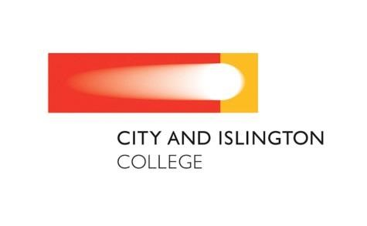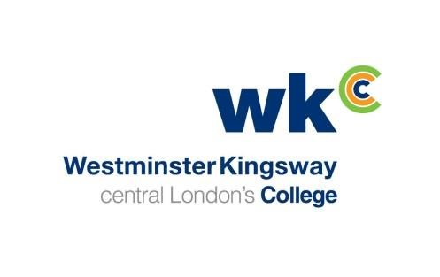

JOINT STATEMENT
WESTMINSTER KINGSWAY COLLEGE AND CITY AND ISLINGTON COLLEGE

AGREEMENT TO MERGE

City and Islington and Westminster Kingsway Colleges are pleased to announce their intention to merge on 1 August 2016 following separate meetings of their respective Board of Governors.

Governors at both colleges met on 9 December 2015 to consider options with respect to closer collaboration. Taking into account the operating context of each college and available evidence as to the benefits of different models of collaboration, Governors concluded that merger would best serve the interests of students, staff and employers.

Governors responded to feedback from the consultation earlier in the autumn by confirming that the existing names and brands of the colleges will be retained. This will allow both colleges to build on their highly successful reputations. City and Islington College is nationally recognised for Science, Technology, Engineering and Maths; and Westminster Kingsway in Hospitality and Catering as well as having the largest apprenticeship programme of any college in London.

A merger will allow students to benefit from a wider curriculum choice than either college can offer individually, with more opportunities to progress onto a wider range of courses across academic, work based and vocational disciplines.

Whilst working for a larger and more resilient college, staff will also benefit from a collaborative approach to curriculum development, quality and continuing professional development (CPD).

Governors from both colleges considered a range of other due diligence evidence to ensure that neither party had unforeseen barriers to prevent merger. It was also agreed that in January a shadow board would be established, consisting of governors from both colleges. One of the first tasks of the shadow board will be to appoint a Chair of the new Corporation.

Ruth Duston, Chair of Governors at Westminster Kingsway College said "The merger between these two high performing colleges will result in an improved experience for students and staff, whilst giving a stronger voice to Further Education at a London and national level”.

Alastair Da Costa, Chair of Governors at City and Islington College said, "I am delighted that the two boards have agreed to merge. This is a really positive and bold move which will enable us to meet the needs of Londoners and those students who travel from other parts of the South East, to benefit from the specialist training and education that both colleges deliver”.

Based on 2014-15 figures, the two colleges will enrol 26,500 students, of which 7,500 will be aged 16-19 and 2000 will be apprentices, with a combined total income of £84 million.

